# Creating docker instance in AWS EC2 instance

After creating a EC2 Linux instance in AWS, follow the below linux commands

1. sudo yum update –y (For linux updates)
2. sudo yum install –y docker (Installing docker setup)
3. sudo groupadd docker (for non root users to avoid permissions, add docker group)
4. sudo usermod –a -G docker $USER (adding current user to docker group, a means add, G means group and its name then user name($user gives current user)) Logout and login (restart) to get changes reflected.
5. Docker –version (to know docker installed or not), sudo su (to login as root user), docker info

# AWS

## AWS Regions and AZ (Availability Zone)

AWS has regions around the world with names like us-east-1, ap-southeast-2 etc. Each region has Availability zone AZ (us-east-1a,us-east-1b..).Each AZ is a physical data center in the region but separate from other AZ to isolate from disasters. **All AWS consoles are region scoped except the IAM and S3 (these 2 are global services rest all require AZ).**

## IAM (Identity and Access Management)

Whole AWS security users, groups, roles are maintained here. Root account should not be used. All services will use IAM so it needs to be properly maintained. **Policies are written in JSON.** As discussed above IAM has global view, can setup Multi Factor Authentication(MFA) for users. Has predefined policies also like admin etc. or we can create ours.

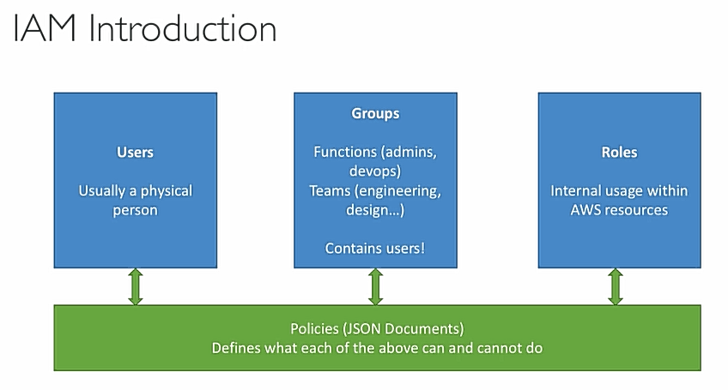

Big enterprises integrates their own repository of users with IAM, this way they can login into AWS with company credentials (like we login into outlook using company email but not microsoft). This is called IAM Federation. This identity federation uses the SAML standard (security assertion markup language which enables SSO (single sign on) authentication by passing authentication credentials to service providers) (active directory).

**Best practices:** One IAM User per physical person, One IAM role per application, Don’t write IAM credentials in code, never use root account account for anything except initial setup, never share the credentials.

### Security Credentials

**Password** to login to account, **MFA** to generate code during login, **Access Keys** – To make programmatic calls to AWS from AWS CLI, powershell, AWS SDKs, API calls etc. Can have maximum 2 access keys.

**CloudFront Key pairs** – we can configure key value pairs to use them anywhere inside EC2, like create a key called name and give value of your name and you can use that variable everywhere. If we want to change name we can change the variable directly

**X.509 certificate** – These certificates are used to make secure SOAP-protocol requests to AWS services like S3 etc.

**Account Identifiers** – AWS account ID a 12 digit account ID to refer our account programmatically and in other contexts and a Canonical User ID to configure S3 access controls lists.

To create a new IAM user, we give their username, access permissions, roles like administrator access etc (we can define these roles through groups), their password defined. However we directly should not assign roles and permissions to each user individually, so we create groups with their permissions like admin group and what permissions they have inside that group then we will assign that group to all the admin users. Next is IAM password policy in which we can set the password policy (like length, complexity etc.) of the users. So by this almost all 5 steps are green in IAM and we are good to go. Edit our account login URL and change the alias from account ID number to anything unique and easy to access. Generally alias will be org name so the sign in URL looks like eg: <https://infosys.signin.aws.amazon.com/console> then we will login with created IAM user credentials. Keep the root account aside and use the created IAM user from now.

## EC2

Renting Virtual Machine (EC2), it consists following services also - Storing data on virtual drives (EBS), Distributing load across machines (ELB), Scaling the services using auto-scaling groups (ASG)

We can launch EC2 mirco instance with linux or windows OS, start/stop them.

To create a EC2 image, first we select the Amazon machine image (linux,windows,redhat,…which some are free tier ) then we will select the type of instance that is t2 micro, no of virtual CPUs, memory, network performance, whether EBS is enabled or not etc. Then we configure instance by checking up options like network which is default vpc, subnet (AZs) and then under advanced options we have User Data which means commands to run at instance start (discussed deeply below), IAM role follow or not etc. Then proceed to storage details which is EBS volume like amount of storage, type of storage to be used etc. then in next step we can define tags which are key value pairs to be used inside EC2 instance, name tag is important cause it shows in UI. Then we move to security which acts like firewall, we can create a new security group or create a new one there by giving type, protocol, source(allowable IP, 0.0.0.0/0 means all IPs) etc. then we review and launch. Finally it asks for a key-pair (.pem file) which is of 2 types private and public. Public is for aws stores and private is for user to store so that to connect instance securely like password to login,SSH to allow all will be done by these key-pairs match. So pem file can be downloaded only once during creation of instance and need everytime if we want to connect to the instance.

To use the launched ec2 instance, we access it through SSH

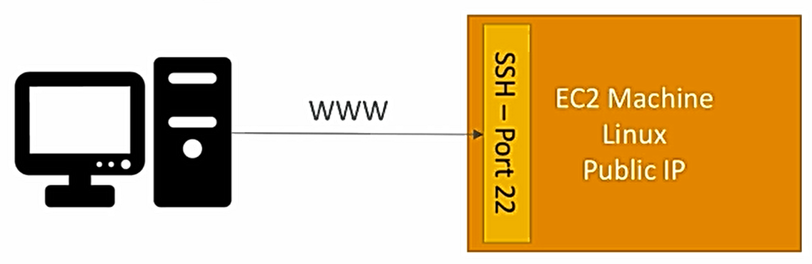

SSH (Secure Shell) is used to connect and control our instance or remote machine using cli. In linux and mac, we will do directly in command line bu doing ssh commands (ssh –i EC2Tutorial.pem [ec2-user@56.189.64.15](mailto:ec2-user@56.189.64.15) , this command will login into our instance) where as in windows we use **Putty (open source SSH client).**

Download putty and install, then open puttygen to convert our .pem file into .ppk file so that putty can read it, just load pem file and save it as ppk. After that open putty and give host IP as the ec2-user @ IP4 address of our instance

Eg: ec2-user@56.189.64.15 , to make it use of ppk file generated, go to SSH under connection on left side navigation and oAuth in it. Give path of ppk file. Save the entire session and save it so that we can use it multiple times, no need to setup everytime. So after successful connection we will connect to instance in cli and run cmds eg:whoami etc.

## Security Groups (SGs)



Acts as firewall of the EC2 instance. They control inbound and outbound traffic, basic feature of cloud, fundamental networking skill to troubleshoot networking issues. So defined inbound rules are not met then we get timeout error if we try to connect to instance. We can create a security group in networking and security section in AWS by giving Type like SSH,HTTP or HTTPs etc., protocol, allowable port range, source like only our IP or matching IP or 0.0.0.0/0 to allow all for IPv6 0.0.0.0/0::0 and then finally description of security group. Like this we can define outbound (instance to outside) rules too.

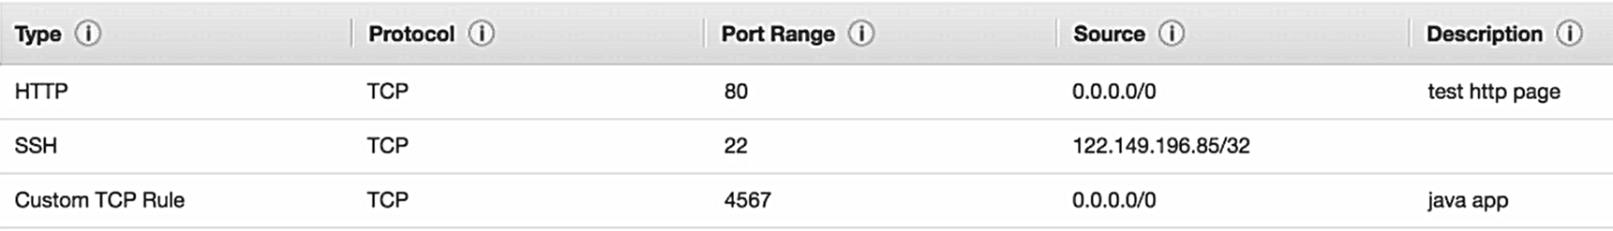

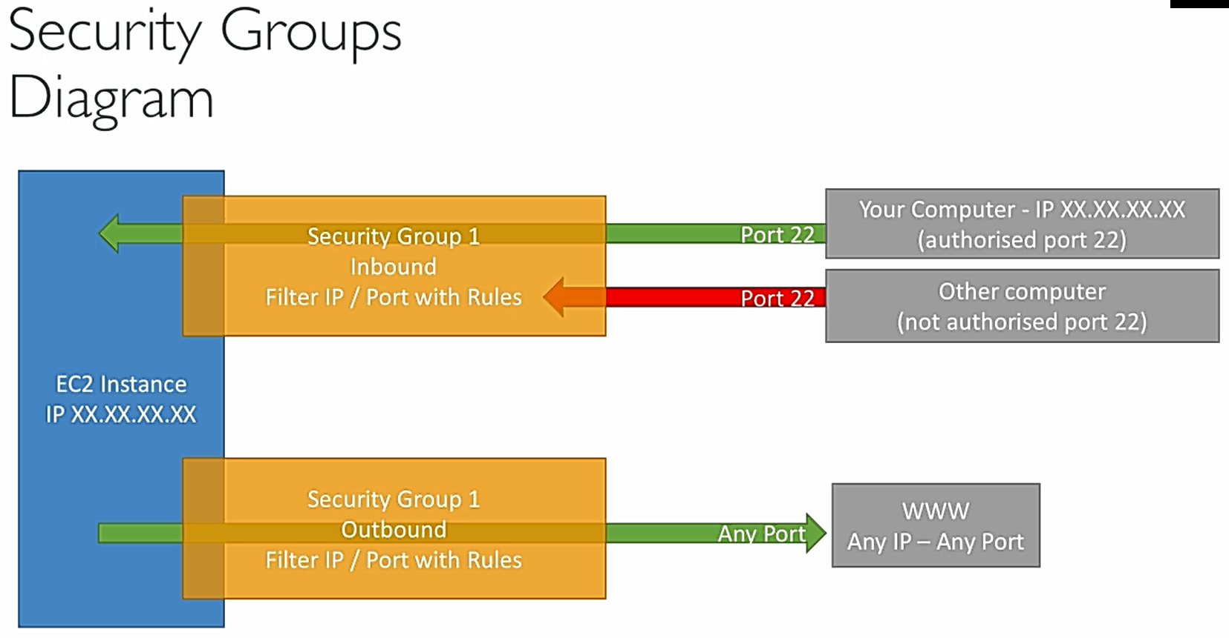

We can also allow traffic if security group matches directly without matching the rules stated. Like in a security group just like how we define allowable IPs etc. we can define allowable other security groups. We will see this in load balancing. Refer below.

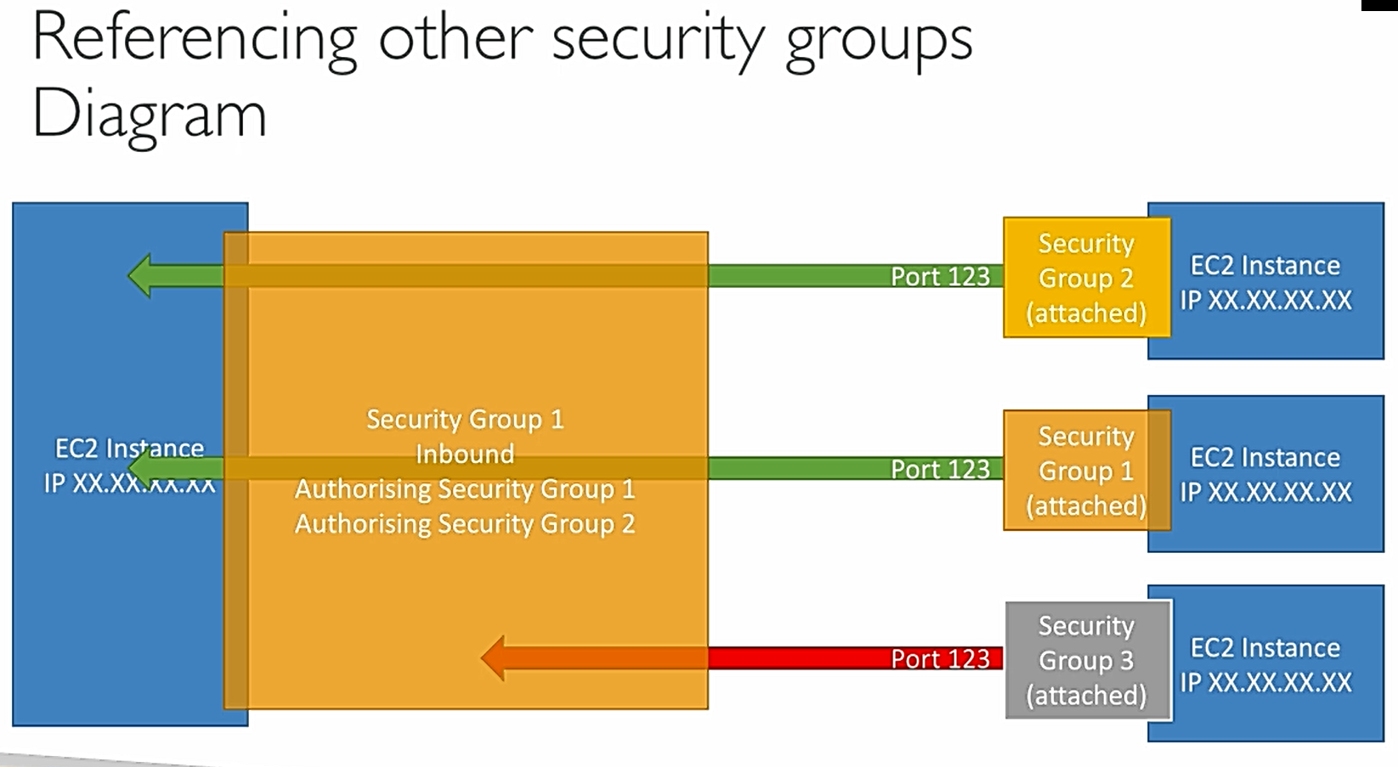

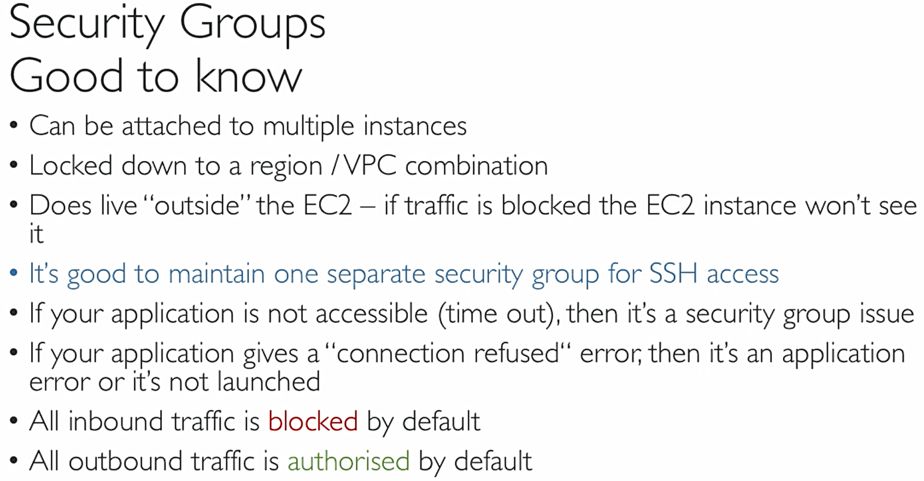

## Networking Public vs Private Elastic IP

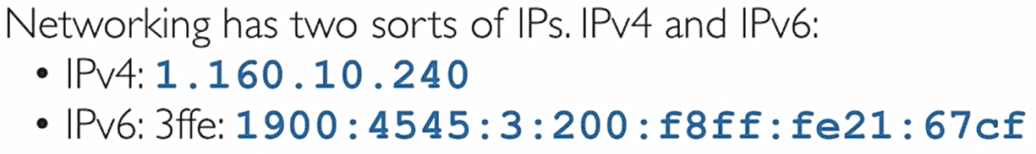

IPv4 is most common format in internet [0-255]. [0-255]. [0-255]. [0-255], IPv6 is newer and used in Iot etc.

When it is public network then we can directly access it through internet whereas if it is private IP then we can access only within that private network, we need internet gateway which is public to access internet.

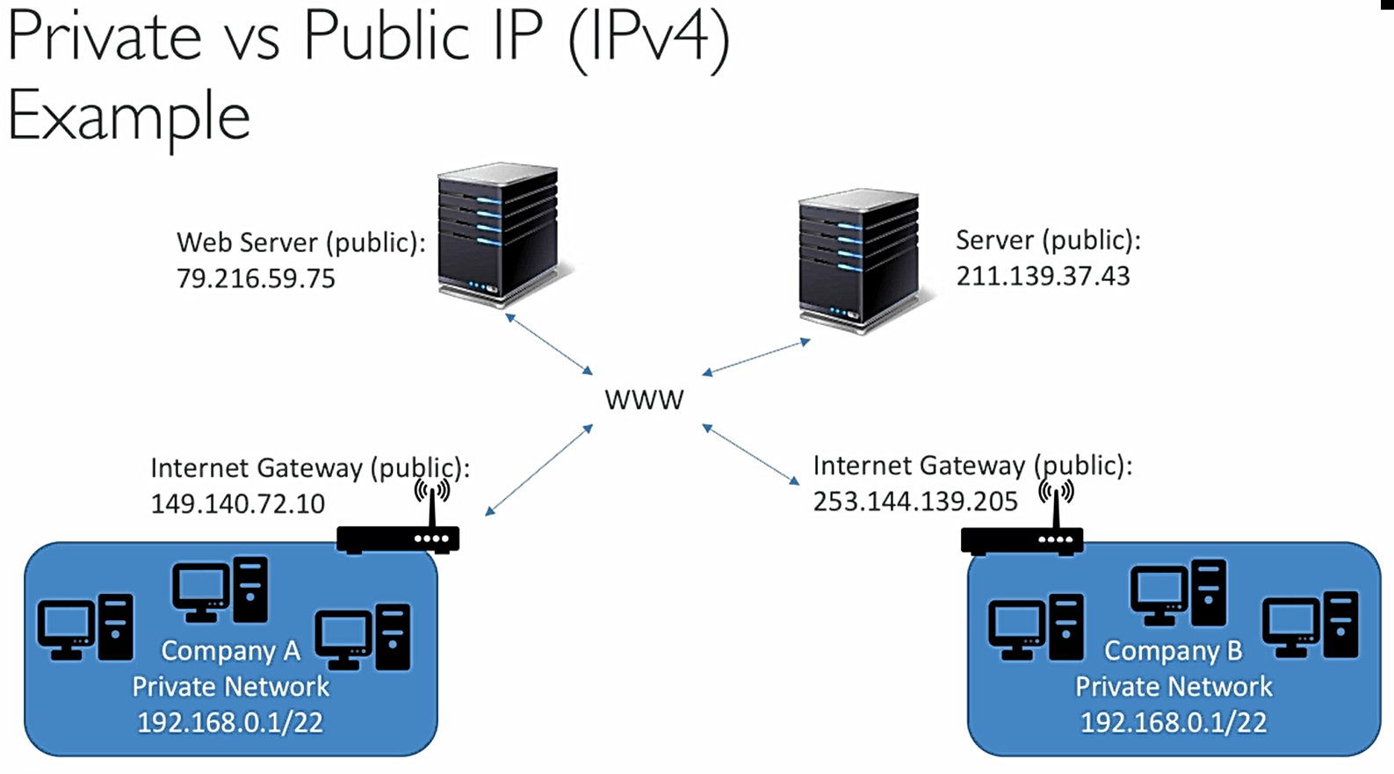

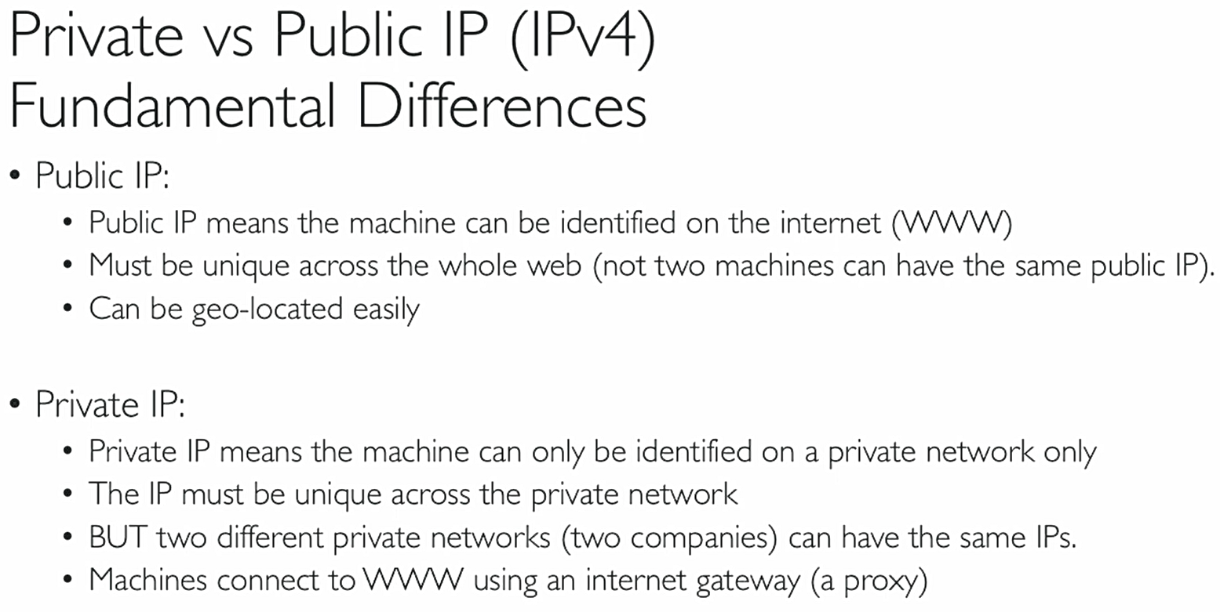

Since every time public IP changes when we restart the ec2 instance, we need to update the ssh command or putty host ip accordingly with new public ip generated, however throughout the instance life cycle the private IP remains same cause it is there in AWS network. We cannot use private IP to connect (timeout error) cause we are not in the same network but once we connect through public IP there we can see in console of putty ec2-user@private IP address cause we are connected to our instance and we are inside AWS network we can see private IP

Regarding the elastic IP (found under Network and security group), create a new elastic IP and we will associate our ec2 instance to it and now if we see the info our instance the public IPv4 address the auto generated one is replaced with the link of elastic IP address. This elastic IP is bound to life cycle of instance just like private IP and doesn’t change even if we restart the instance. We can disassociate by right click options of instance.

Elastic IPs:

° When you stop and then start an EC2 instance, it can change its public IP?

° If you need to have a fixed public IP for your instance, you need an Elastic IP

° An Elastic IP is a public IPv4 IP you own as long as you don't delete it

- You can attach it to one instance at a time

° With an Elastic IP address, you can mask the failure of an instance or software by rapidly remapping the address to another instance in your account.

° You can only have 5 Elastic IP in your account (you can ask AWS to increase that).

° Overall, try to avoid using Elastic IP:

° They often reflect poor architectural decisions

° Instead, use a random public IP and register a DNS name to it

° Or, as we'll see later, use a Load Balancer and don't use a public lP

Private vs Public IP (IPv4)

In AWS EC2 — Hands On

° By default, your EC2 machine comes with:

° A private IP for the internal AWS Network

° A public IP, for the WWW.

° When we are doing SSH into our EC2 machines:

° We can’t use a private IP, because we are not in the same network

° We can only use the public IP.

° If your machine is stopped and then started **the public IP can change**

## Operations on Instance

In this we practise by installing apache webserver to display webpage and creating a html file to display hostname.

Connect to the instance (make sure it is Amazon linux 2 AMI(Amazon machine image)) through Putty or ssh command with latest public IP and then run following commands (“clear” command will clear screen)

1. sudo su :-Gives root access to the user, so that we cann run all commands without asking for permissions

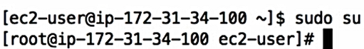

1. yum update –y :- this command will update all packages in machine to the latest versions, -y mean yes to all
2. yum install –y httpd.x86_64 :- install apache server httpd of 86,64 bit and –y yes to all permissions
3. systemctl start httpd.service :- starting the httpd service, systemctl command found in amazon linux 2 only
4. systemctl enable httpd.service :- above command starts and this will enable the service across the reboots
5. curl localhost:80 :-curl means current url and then url this command loads the localhost:80 webpage html which is apache homepage in cli cause apache runs on localhost default 80 port always.
   1. We can see this apache homepage in our browser by url our public IPv4 followed by apache port or only public ip, so kind of looks like 34.45.33.54:80 (assume it’s a public IP). But this will result in time out error.
   2. That’s because in our security group we mentioned by default to use SSH access that too only on 22 port. So enable connection edit the Security group and create a new rule with HTTP connection and port as 80, IP as 0.0.. as of now and reload the previous mentioned url, this time without timeout error the apache homepage will appear which is running in our ec2 instance. If we look carefully, we find

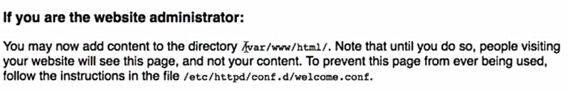

So to appear our stuff instead of apache default homepage on this port we need to edit /var/www/html/. File, the .file is generally index.html

1. echo “hello pavan” > /var/www/html/index.html :-echo command will wirte the content “hello pavan” inside(>) the file of given path. So if we reload the public ip4:80 we see Hello pavan html there. To get the host name command is “hostname –f” this will give ip.AZ… so to display this inside html
2. echo “hello pavan from $( hostname –f)” > /var/www/html/index.html :-shows hello pavan from host details

## EC2 User Data

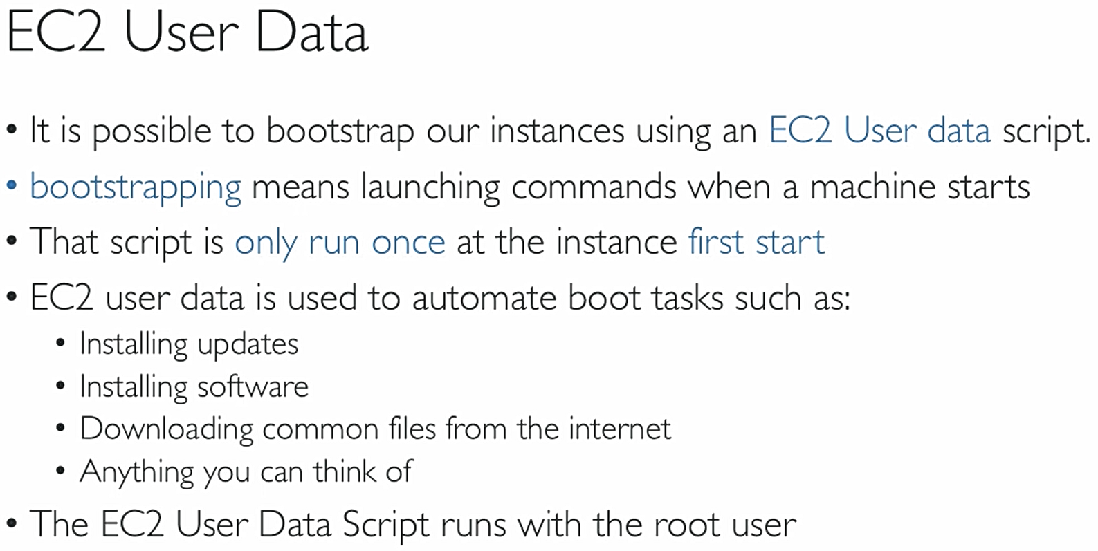

So to automate the apache server and html file edit which we did in above step we give the same commands in user data file. Create a new instance(we can also stop existing one and give user data by right click options) and in user data options repeat following commands and in security group make sure to allow HTTP of port 80 or simply use the existing sg we created above earlier to allow http port 80

we start with #cloud-boothook means this data is boothook data and stored in /var/lib/cloud and executed at booting of insatnce, #!/bin/bash that means we are stating that use only bash to run the following commands, no other shell. Since all commands run on root user mode, no need to write sudo su command. Also before copying below code look for – it will copy differently so edit them (use VS text editor)

#cloud-boothook

#!/bin/bash

yum update -y

yum install -y httpd.x86_64

systemctl start httpd.service

systemctl enable httpd.service

echo "hello from $(hostname -f)" > /var/www/html/index.html

## EC2 Launch Types

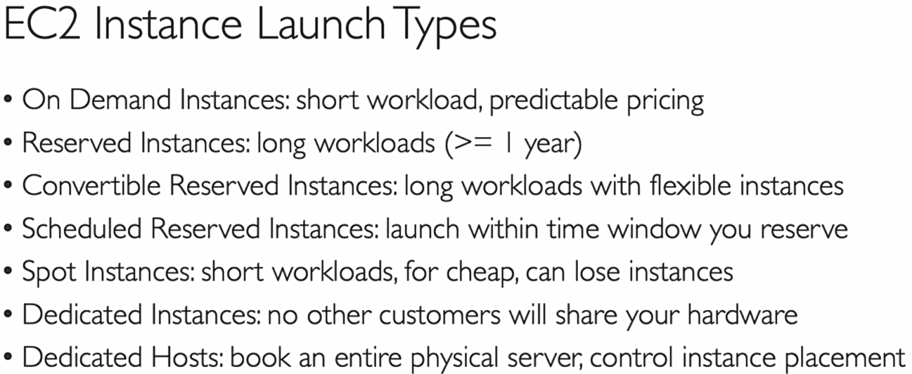

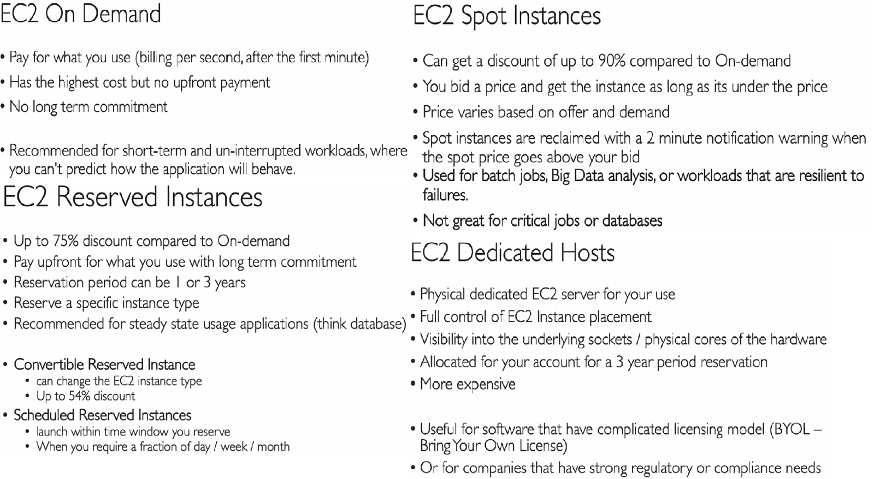

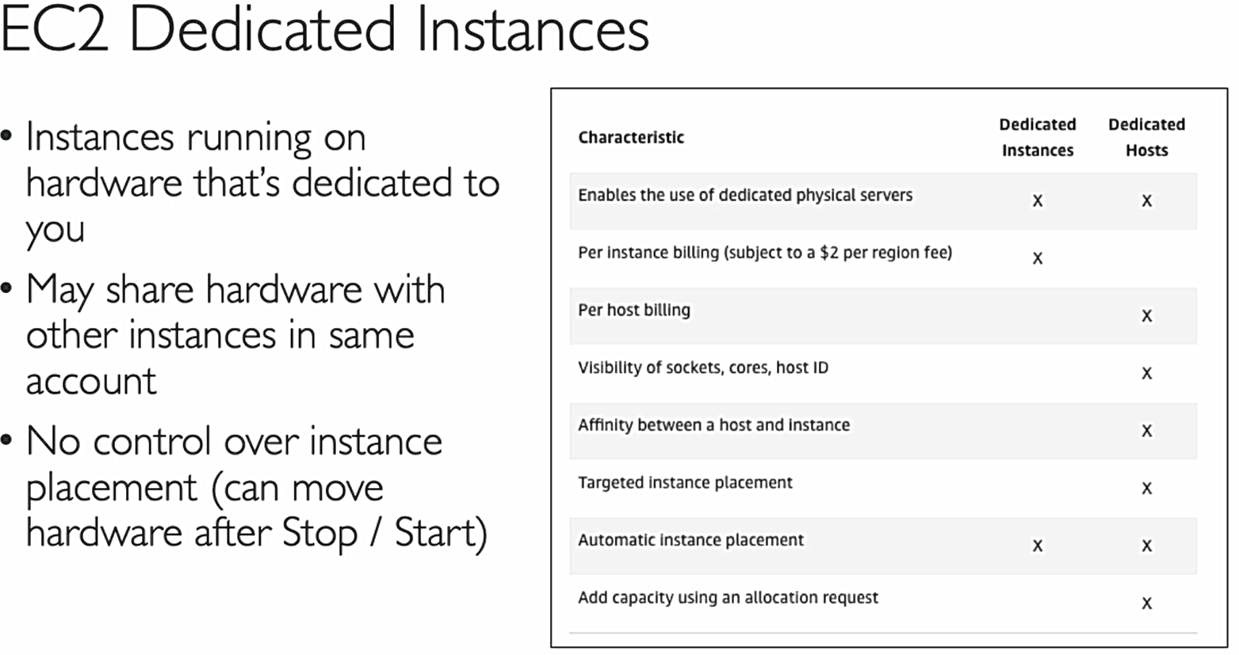

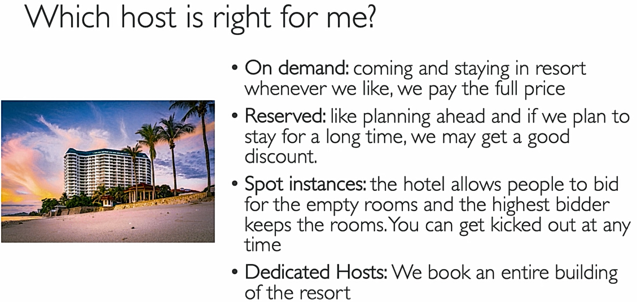

## AMI

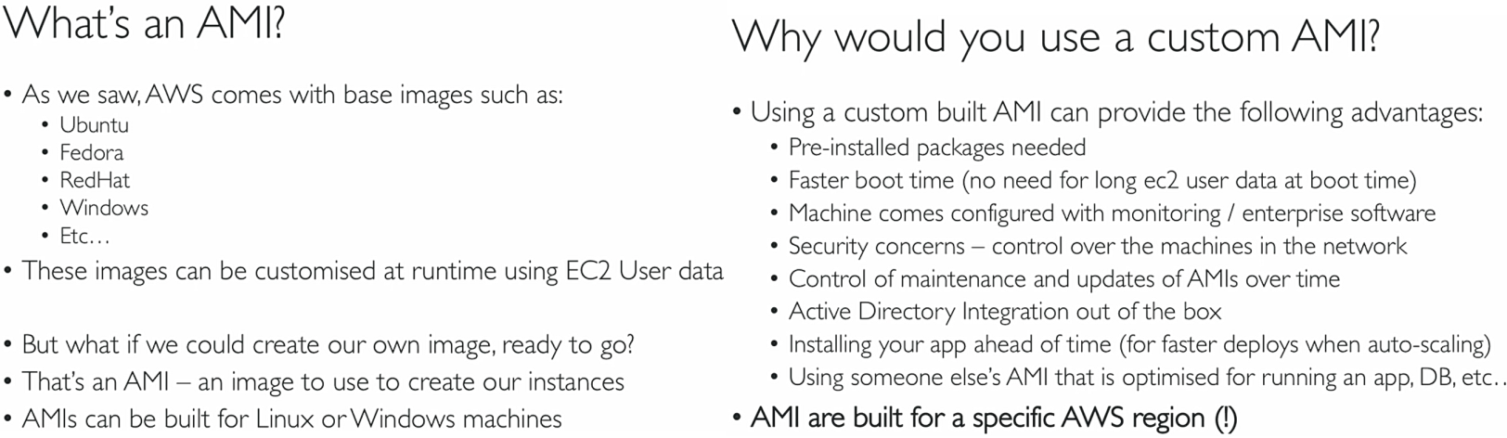

## EC2 Pricing

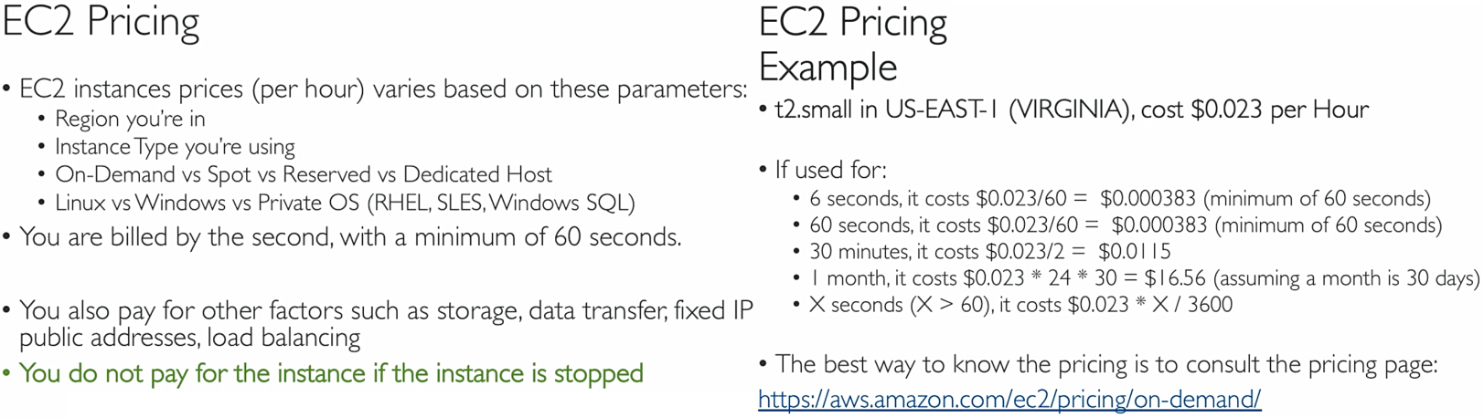

## EC2 Overview

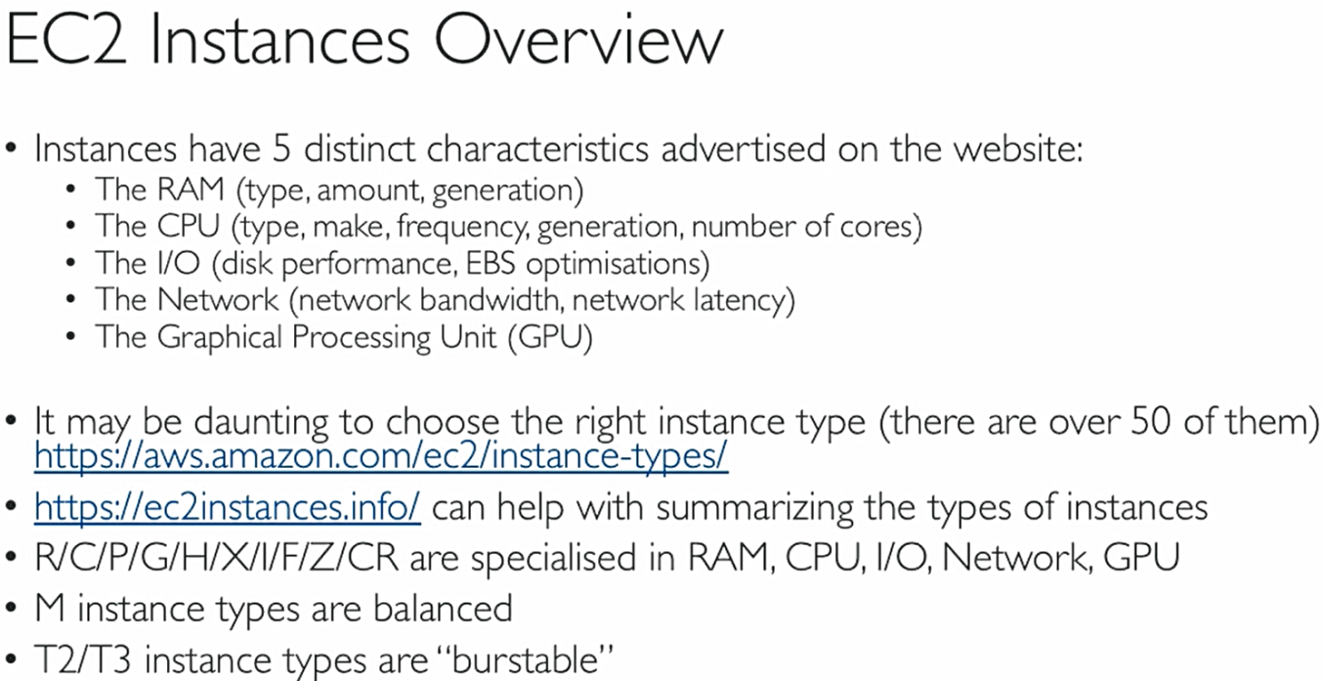

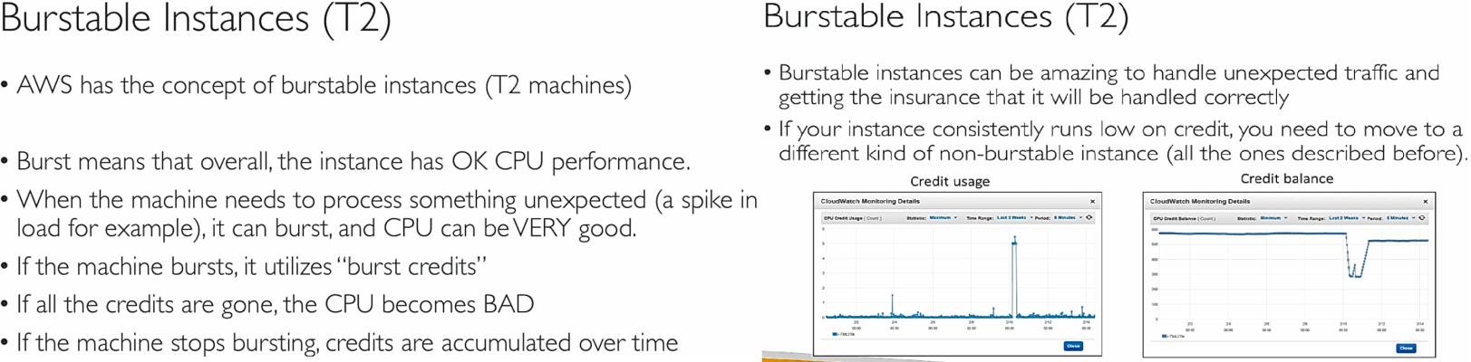

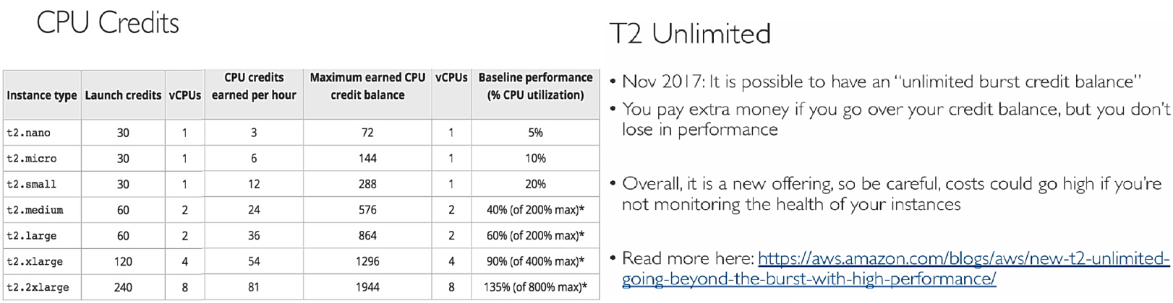

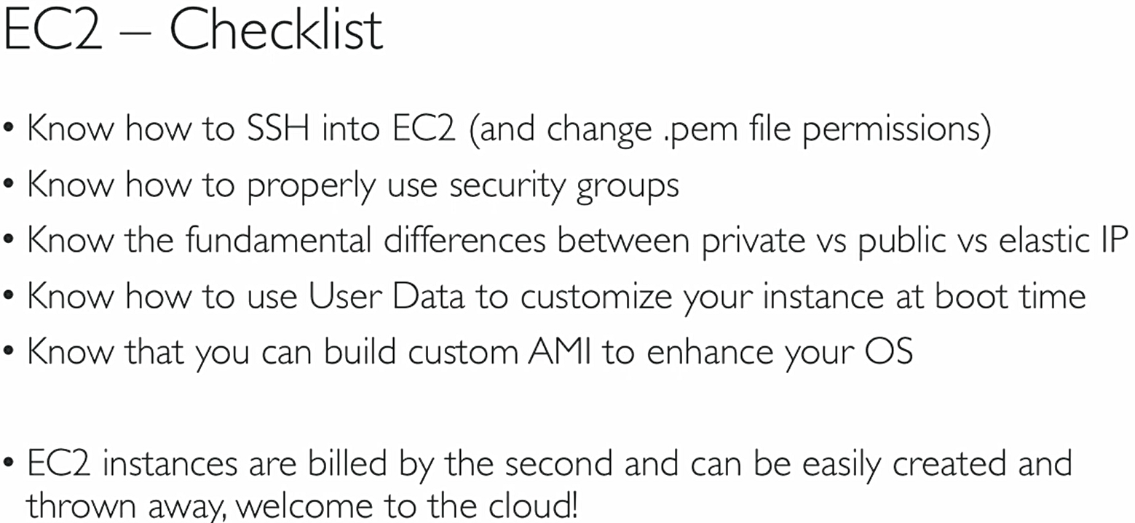

## EC2 Load Balancer (ELB)

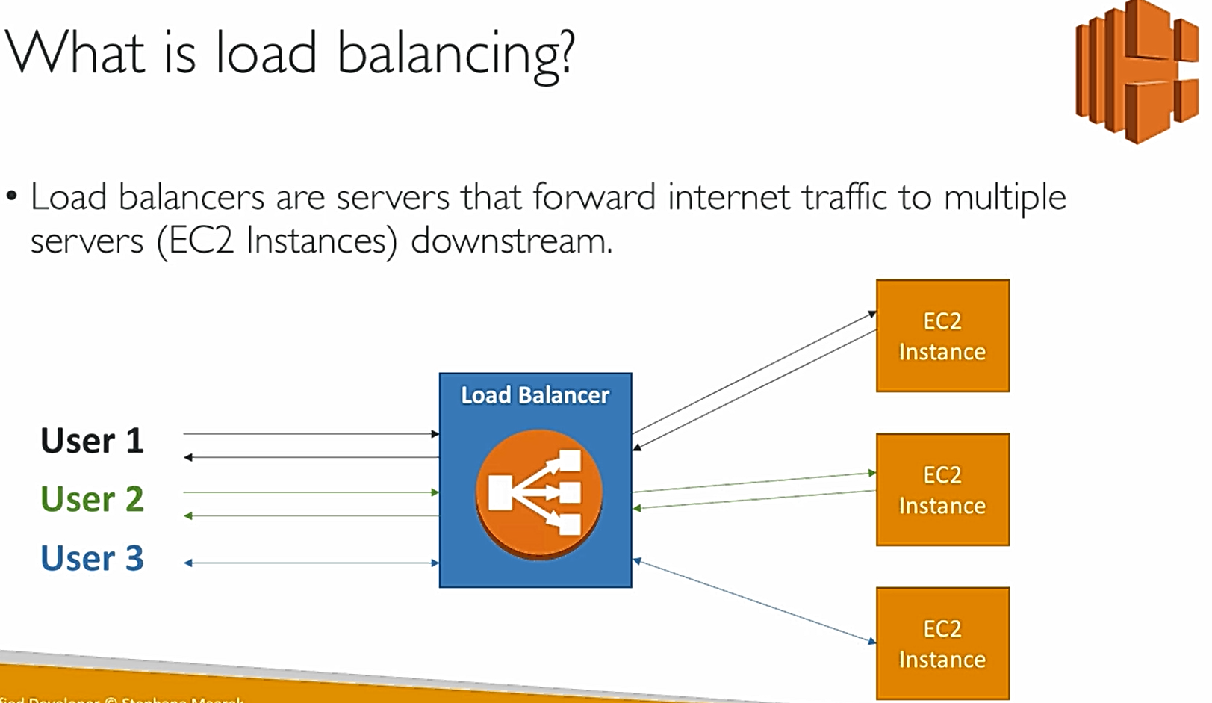

Why use a load balancer?

° Spread load across multiple downstream instances

° Expose a single point of access (DNS) to your application

° Seamlessly handle failures of downstream instances by doing regular health checks to your instances

° Provide SSL termination (HTTPS) for your websites (provides encryption to sites)

° Enforce stickiness with cookies (so that client takes to same instance every time)

° High availability across zones (ELB automatically looks for high availability zones so all our instances too)

° Separate public traffic from private traffic (it can distinct traffic based on type)

Why use an EC2 Load Balancer?

° An ELB (EC2 Load Balancer) is a managed load balancer

° AWS guarantees that it will be working

° AWS takes care of upgrades, maintenance and high availability

° AWS provides only a few configuration knobs

° It costs less to setup your own load balancer but it will be a lot more effort on your end.

It is integrated with many AWS offerings / services

Types of load balancer on AWS

- AWS has 3 kinds of Load Balancers

1) Classic Load Balancer (v1 - old generation) - 2009

2) Application Load Balancer (v2 - new generation) - 20 l 6

3) Network Load Balancer (v2 - new generation) - 20 l 7

°Overall, it is recommended to use the newer/ v2 generation load balancers as they provide more features

° You can setup internal (private) or external (public) ELBs

Health Checks

° Health Checks are crucial for Load Balancers

° They enable the load balancer to know if instances it forwards traffic to are available to reply to requests

° The health check is done on a port and a route (/health is common)

° If the response is not 200 (OK), then the instance is unhealthy

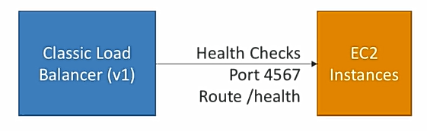

## Application Load Balancer (v2)

° Application load balancers also called as (**Layer 7**) allow to do:

- Load balancing to multiple HTTP applications across machines (target groups)

° Load balancing to multiple applications on the same machine (ex: containers)

° Load balancing based on route in URL

° Load balancing based on hostname in URL

° Basically, they’re awesome for micro services & container-based application (example: Docker & Amazon ECS)

-Has port mapping feature to redirect to dynamic port

- In comparison before, we need to create one classic load balancer per application which is expensive and inefficient.

Here below, load balancing first dividing the target groups for each route, if route is user the target group users matches and same for search route. Like this there can be many target groups to match route. Each target group has many EC2 instances which are load balanced by ELB here. All these instances are health checked by the rules we define. If any instance fails the health check then load balancer won’t send any request to that. So load balancer acts as both load balancer and matching routes & targets. Network load balancer also same but instead of load balancing based on route or http traffic used in ALB, they do based on TCP traffic (you will see next to this)

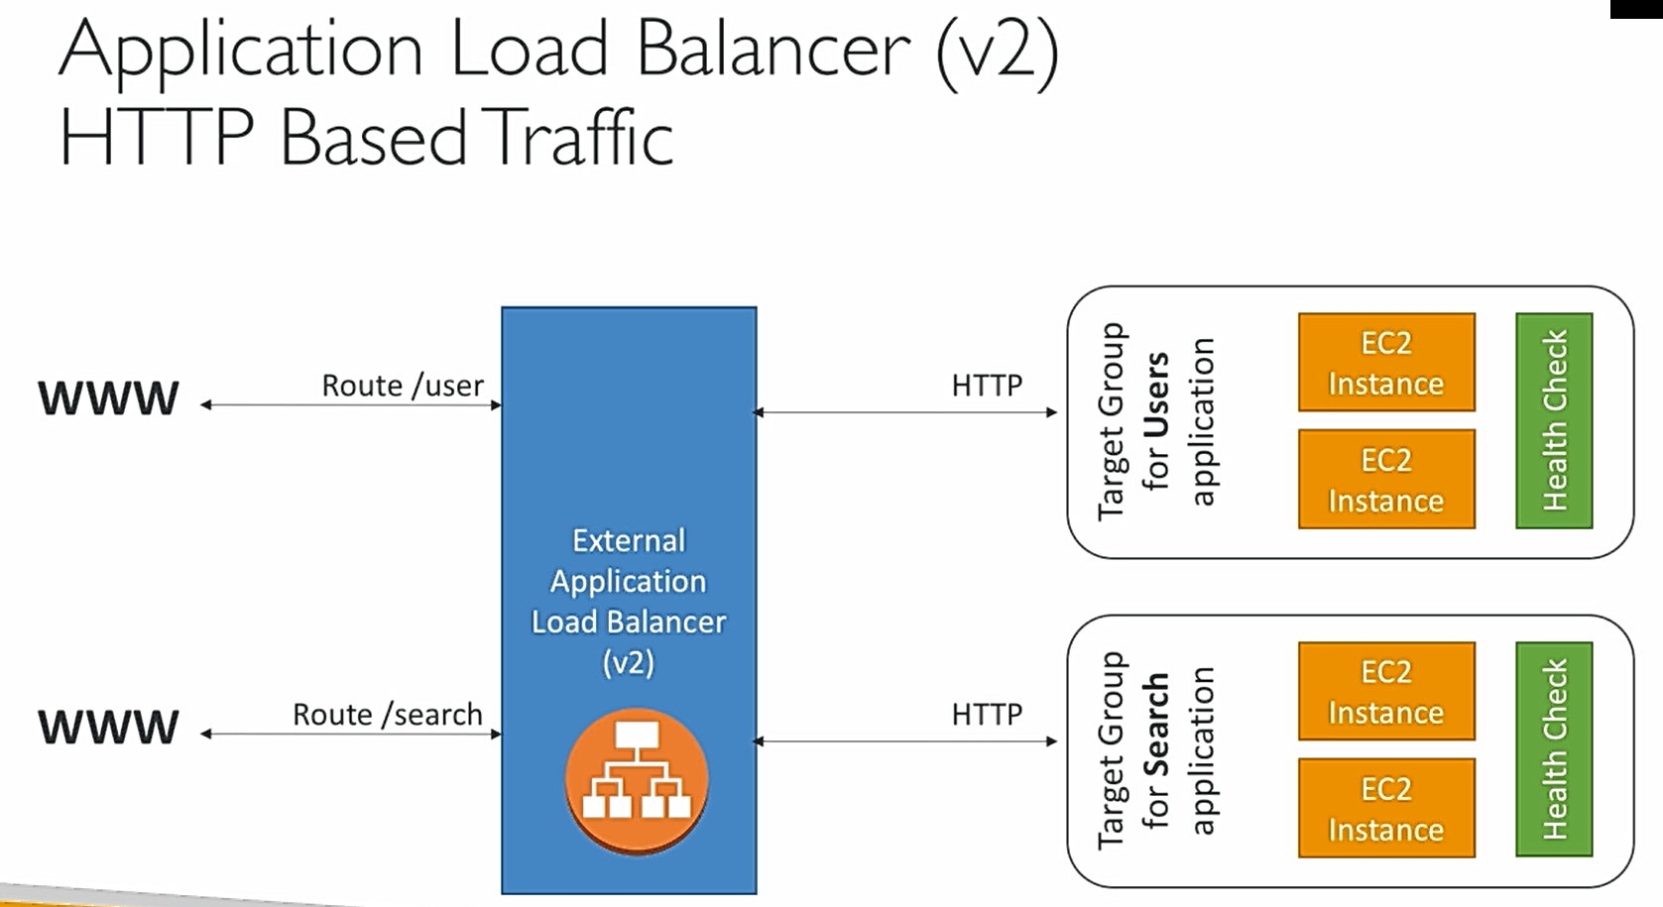

So the load balancer not pass the details of the client to the ec2 application, we can see only private IP of load balancer in our instance. However to know the client private IP and port etc. details we need to look after the request header **X-Forwarded-For** (as shown below)

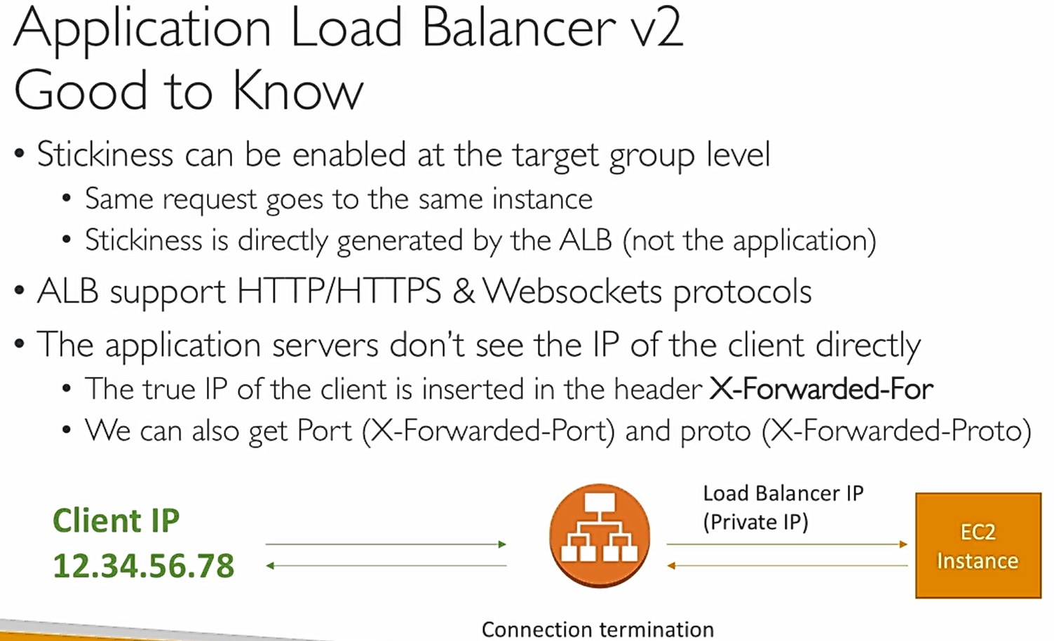

## Network Load Balancer (v2)

° Network load balancers (**Layer 4**) allow to do:

° Forward TCP traffic to your instances

- Handle millions of request per seconds

-Support for static IP or elastic lP, EC2 can see client IP no need of X-forwarded-for header

° Less latency ~ 100 ms (vs 400 ms for ALB) (latency means response, ms means milliseconds). So if we need high performance then we use NLB

° Network Load Balancers are mostly used for extreme performance and should not be the default load balancer you choose, creation is same as ALB.

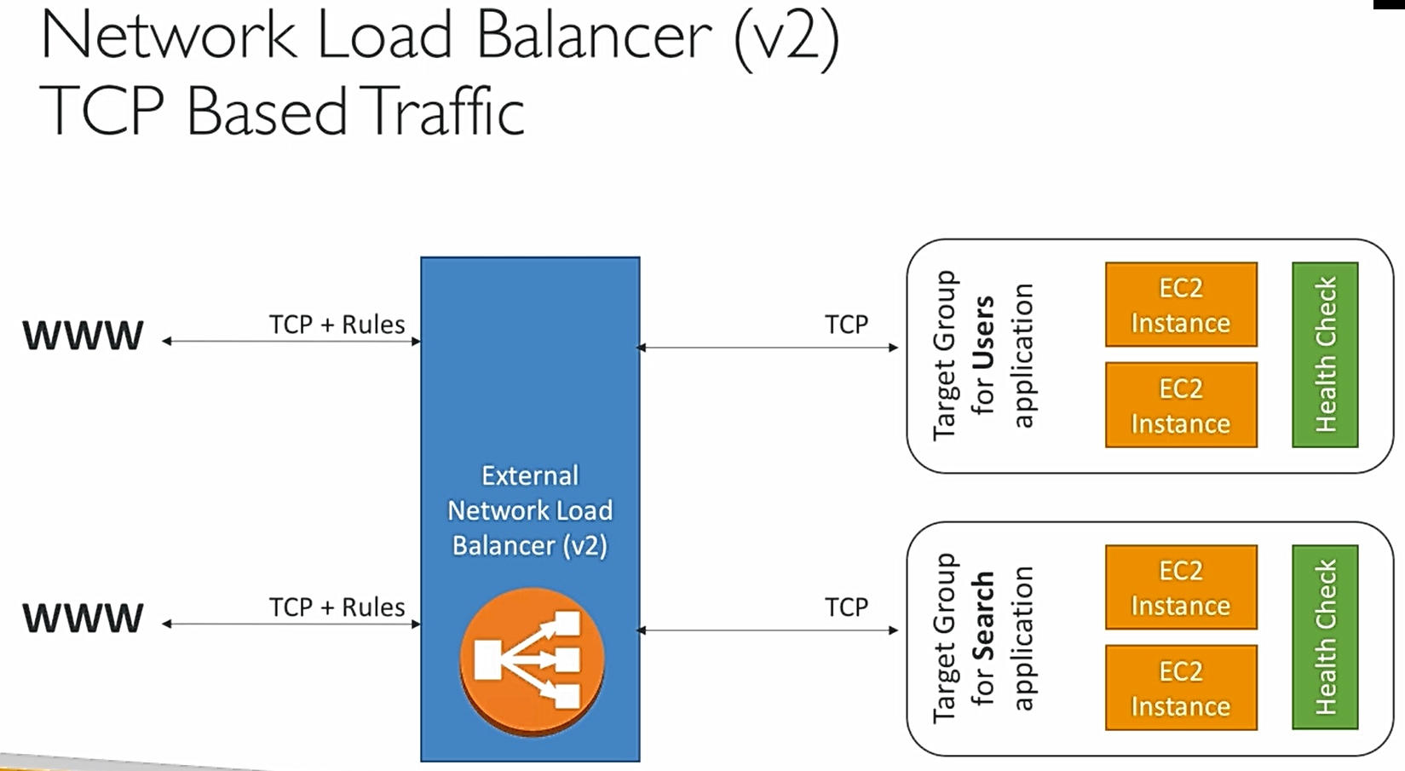

**Load Balancer Good to Know**

° Classic Load Balancers are Deprecated

° Application Load Balancers for HTTP/ HTTPs &Websocket

° Network Load Balancer for TCP

° CLB and ALB support SSL certificates and provide SSL termination

' All Load Balancers have health check capability

° ALB can route on based on hostname / path

° ALB is a great fit with ECS (Docker)

° Any Load Balancer (CLB,ALB, NLB) has a static host name. Do not resolve and use underlying IP (important)

° LBs can scale but not instantaneously — contact AWS for a “warm-up”

' NLB directly see the client IP (no need of x-forwarded-for like ink ALB)

' 4xx errors are client induced errors

' 5xx errors are application induced errors

° Load Balancer Errors 503 means at full capacity or no registered target

' If the LB can’t connect to your application, check your security groups!

**Hands On**

Select Load balancer from left side, Create load balancer > Select the ALB or NLB or CLB, we go with ALB now > give name for LB, scheme type internet-facing means public through internet, internal means within private, listeners means in which port the LB should listen and then select AZs > create a new LB security group > configure routing by create a target group and then the protocol and ports the instance targets are running, since apache running on http 80 we give the same, then the health check details > register running instances into the target group >launch

**We use DNS of the ELB to use it**

So if everything is fine, if we hit LB DNS url then we see our EC2 output which we gave inside the target. The same EC2 can also be accessed by hitting that EC2 machine public IP (old native method we used before). So to make that instance only accessible through LB but not directly edit the Security group of EC2 and then in the allowable IP regEX give the Load balancer Security group (remember in the Security group topic above there is a point that one sg can refer another sg to allow through it, here we are implementing the same). So now only the traffic from LB sg can access the instance but no the public IP or elastic IP if any (results in timeout error as expected).

## Auto Scaling Group (ASG)

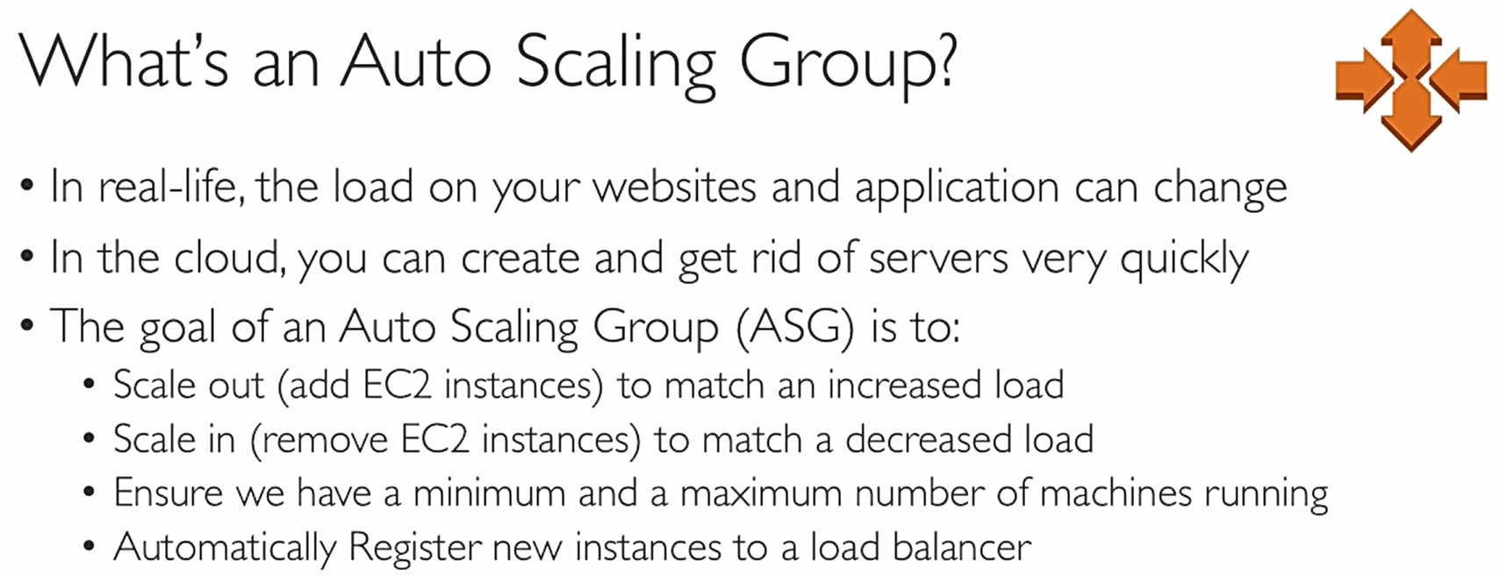

** Scale Out – Adding Instances, Scale In – Removing Instances

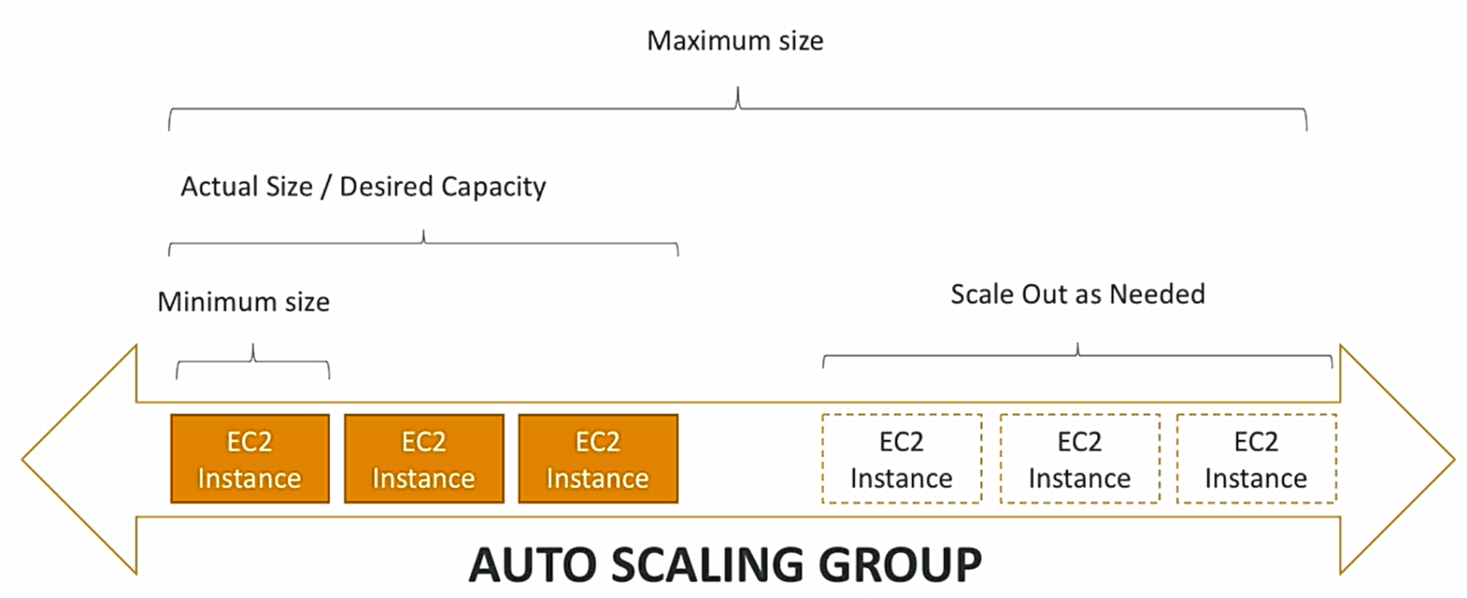

Both ASG and Load balancer work hand in hand in AWS, below figure illustrates how it is done. The newly scaled out instances will also undergo Load balancer Health checks and takes traffic from LB.

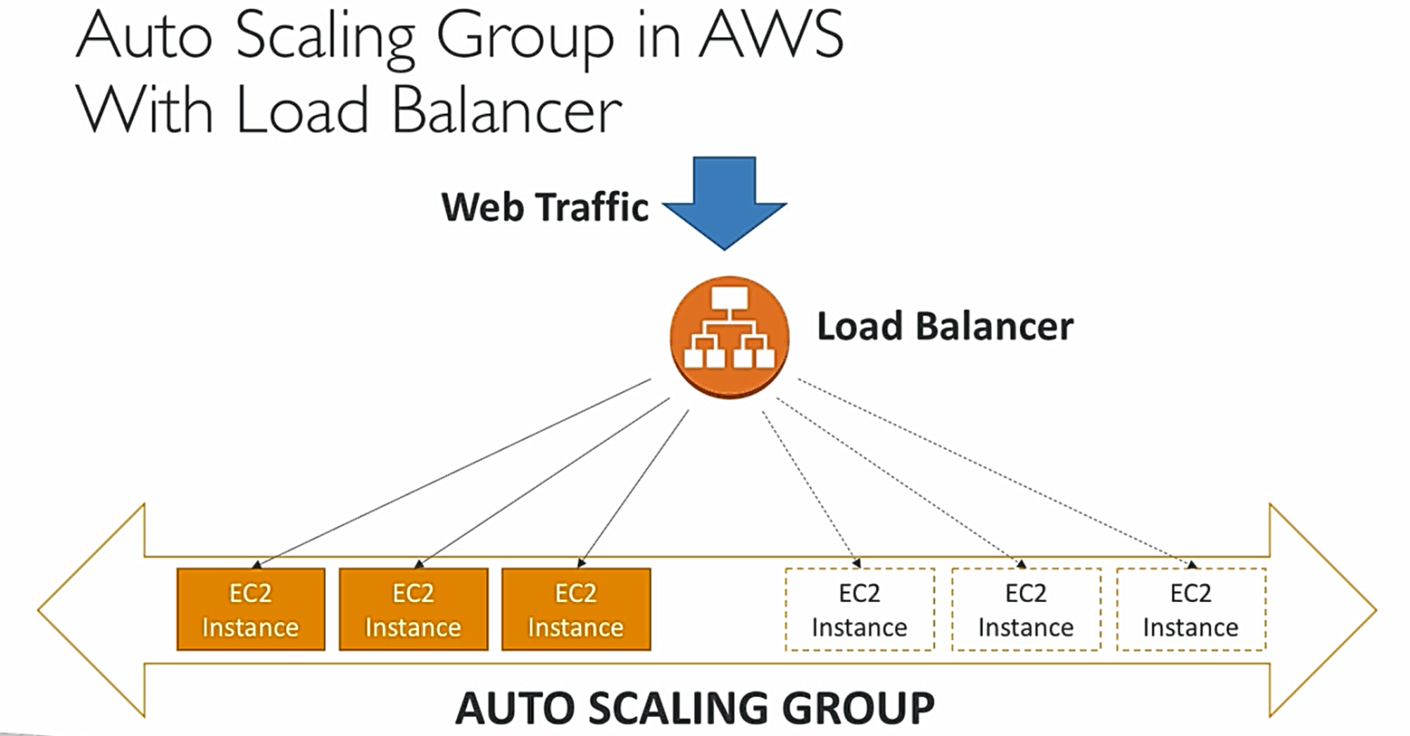

ASGs have the following (almost the same info we give if we create manual instance)

° A launch configuration

° AMI + Instance Type

° EC2 User Data

° EBS Volumes

° Security Groups

° SSH Key Pair

° Min Size / Max Size / Initial Capacity

- Network + Subnets Information

° Load Balancer Information

-Scaling Policies (like when to scale, max, min, desired number of instances)

We can set ASG by CloudWatch alarms which comes in later part of the course (don’t dive deep here)

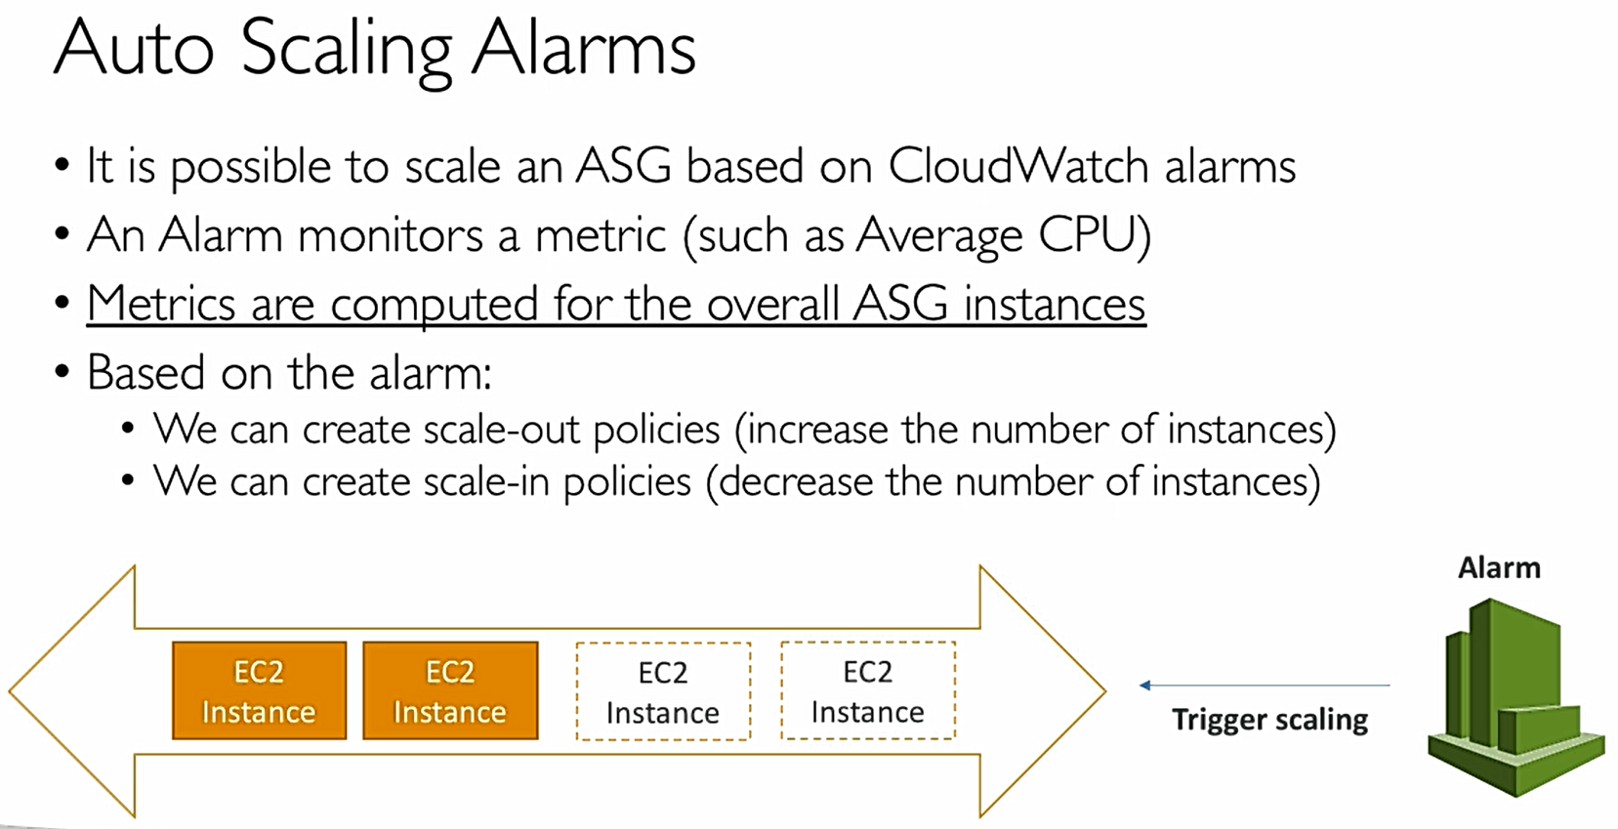

In Earlier, there are complicated rules for scaling policies but now there are more simplified

Auto Scaling New Rules

° It is now possible to define “better” auto scaling rules that are directly managed by EC2

° Target Average CPU Usage

° Number of requests on the ELB per instance

-Average Network In

° Average Network Out

- These rules are easier to set up and can make more sense

Auto Scaling Custom Metric thorough CloudWatch

° We can auto scale based on a custom metric (ex: number of connected users)

° 1.Send custom metric from application on EC2 to CIoudWatch (PutMetric API)

° 2. Create CIoudWatch alarm to react to low/ high values

° 3. Use the CIoudWatch alarm as the scaling policy for ASG (so like this we can use any custom metrics to scale)

ASG learnt so far:

° Scaling policies can be on CPU, Network... and can even be on custom metrics or based on a schedule (if you know your visitors patterns)

° ASGs use Launch configurations and you update an ASG by providing a new launch configuration

° IAM roles attached to an ASG will get assigned to EC2 instances

° ASG is free. You pay for the underlying resources being launched

° Having instances under an ASG means that if they get terminated for whatever reason or accidentally, the ASG will restart them. Extra safety!

° ASG can terminate instances marked as unhealthy by an LB (and hence replace them) So no resources allocated to unhealthy useless instances.

**Hands On**

Go to ASG and first create a new launch config > follow the same steps when we create a new instance > create

After creating launch config, create ASG with this > give name, group size (no of instances), subnets (AZ), load balancer details in advanced details, ignore CLB, give the target group > configure scaling policies like no of instances 1 to n, metric type > ignore notification and tags etc. > review and launch (if any error just retry) (also make sure to keep health checkup value default like cooling period 300, health check grace period, instance warm up period 300 etc. else what happens is health check happens before the completion of scripts an results in unhealthy)

## EBS Volumes

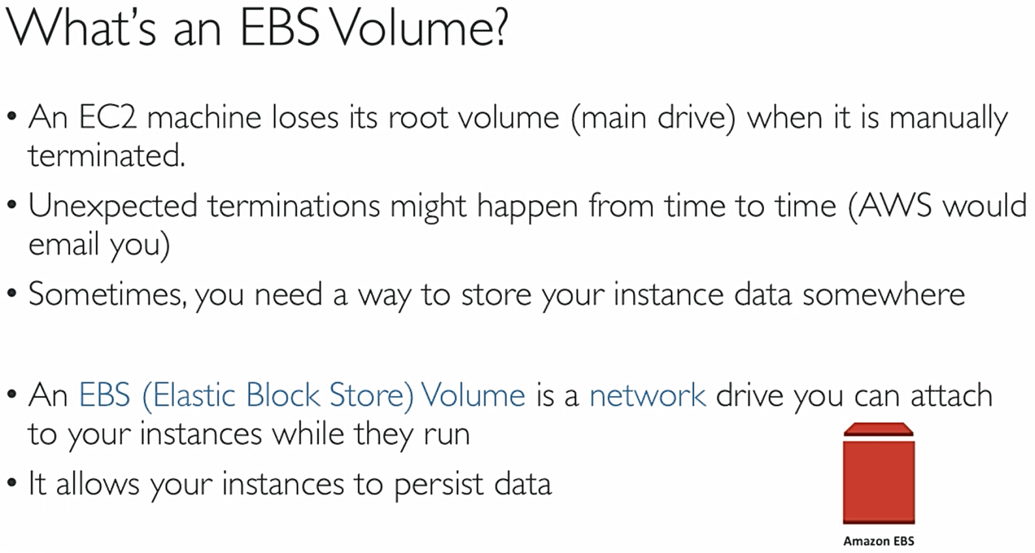

EBS Volume

- It’s a network drive (i.e. not a physical drive)

° It uses the network to communicate the instance, which means there might be a bit of latency but the advantage is

It can be detached from an EC2 instance and attached to another one quickly

-It’s locked to an Availability Zone (AZ)

° An EBS Volume in us-east-1a cannot be attached to us-east-2b

° To move a volume across, you first need to snapshot it (discussed later)

° Have a provisioned capacity (size in GBs, and IOPs (Input Output Operations))

° You get billed for all the provisioned capacity (used capacity)

° You can increase the capacity of the drive over time.

-EC2 instances are tied to the EBS volumes individually like shown below

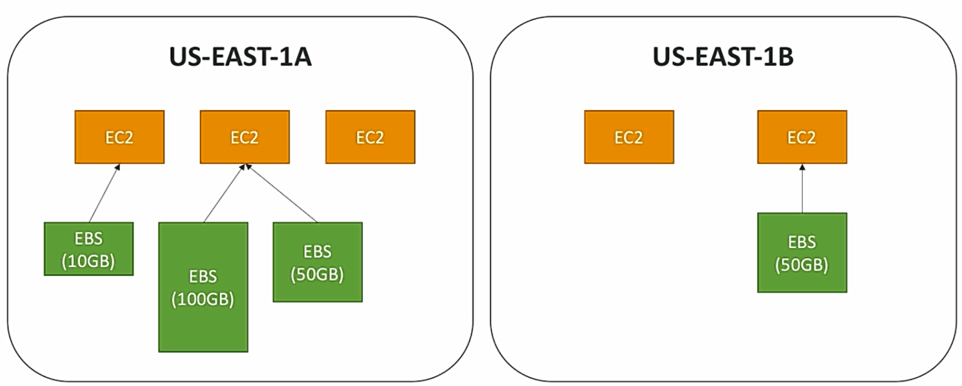

### EBS Volume Types

- EBS Volumes come in 4 types

° GP2 (SSD): General purpose SSD volume that balances price and performance for a wide variety of workloads

° IO1 (SSD): Highest-performance SSD volume for mission-critical low-latency or high – throughput workloads, expensive

° STI (HDD): Low cost HDD volume designed for frequently accessed, throughput-intensive workloads for example big data apps

° SCI (HDD): Lowest cost HDD volume designed for less frequently accessed workloads

° EBS Volumes are characterized in Size |Throughput | IOPS

° When in doubt always consult the AWS documentation — it’s good!

° We’ve been only using GP2 volumes so far

### EBS Volume Resizing

° Feb 2017: You can resize the EBS volumes

° You can only increase the EBS volumes:

° Size (any volume type)

° IOPS (only in IO1)

° After resizing an EBS volume, you need to repartition your drive

### EBS Snapshots

° EBS Volumes can be backed up using “snapshots”

° Snapshots only take the actual space of the blocks on the volume

° If you snapshot a IOOGB drive that only has 5 GB of data, then your EBS snapshot will only be 5GB

- Snapshots are used for:

° Backups: ensuring you can save your data in case of catastrophe

- Volume migration: Resizing a volume down, Changing the volume type, Encrypt a volume

### EBS Encryption

° When you create an encrypted EBS volume, you get the following:

° Data at rest is encrypted inside the volume

° All the data in flight moving between the instance and the volume is encrypted

° All snapshots are encrypted

° All volumes created from the snapshot are also encrypted

° Encryption and decryption are handled transparently (you have nothing to do)

- Encryption has a minimal impact on latency, so always use this

-EBS Encryption leverages keys from KMS (AES-256) (see further)

- Copying an unencrypted snapshot allows encryption

### EBS vs Instance Store

- Some instance do not come with Root EBS volumes

- Instead, they come with “Instance Store”.

- Instance store is physically attached to the machine

- Pros:

° Better I/O performance

- Cons:

° On termination, the instance store is lost

° You can't resize the instance store

° Backups must be operated by the user

° Overall, EBS-backed instances should fit most applications workloads

### EBS summary

-EBS can be attached to only one instance at a time

° EBS are locked at the AZ level

° Migrating an EBS volume across AZ means first backing it up (snapshot), then recreating it in the other AZ

- EBS backups use IO and you shouldn’t run them while your application is handling a lot of traffic

° Root EBS Volumes of instances get terminated by default if the ECZ instance gets terminated. (You can disable that)